Can I stream to Youtube from a USB Camera?
Yes you can!
It can seem a little daunting at first, but streaming to YouTube from a USB camera is actually very easy. To get started the few things you will need are an operational HuddleCam and an active YouTube account.
Let’s start by logging into YouTube.
You should be able to click on 3 little horizontal lines in the upper left of the home screen.
Go to “My Channel”
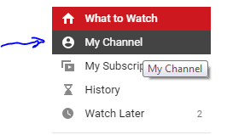
Now, you should be able to select the “Video Manager” tab from below the search bar.
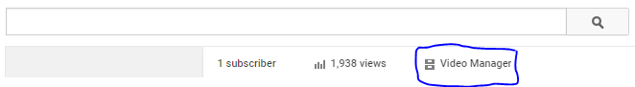
Go to “Live Events” and click the button on the top-right to create “New Live Event”
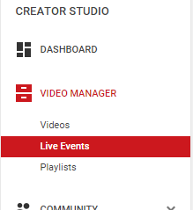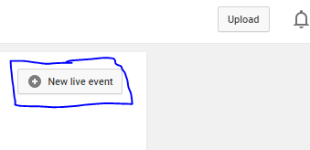
Next name your event, schedule a time for it, and set as public or private.
For the “Type”, make sure it is set to “Custom”.
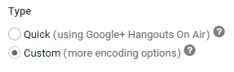
Next, choose a bit rate that suits your available bandwidth.
From testing with the cameras it has been found that 720P does an excellent job of providing a quality streaming experience without utilizing too much bandwidth.
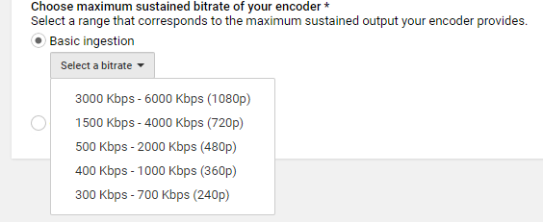
Once you select your bitrate you will have to choose your Encoder.
I will start off by explaining the Flash Media Live Encoder first then we will look at Wirecast.
Select Flash Media Live Encoder from the dropdown menu.
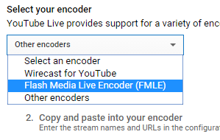
Next, you will be instructed to download the latest version of the encoder from Adobe.
Then you will need to download a settings profile for Flash Media Live Encoder. This profile is based off of your previous settings, so if you make a new stream, you will need a new profile.
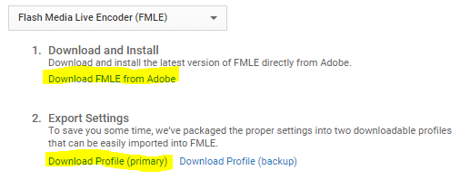
Open the downloaded Flash Media Live Encoder software and complete the installation process.
Load the downloaded profile into FMLE by clicking on “File” in the FMLE software.
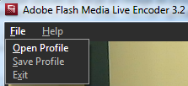
(If you receive any errors in regards to inccorect tags or values please continue on as this can be normal behavior depending on Google Account Settings)
Next setup you camera and audio source(s) for the YouTube Live stream using the available dropdown menus.
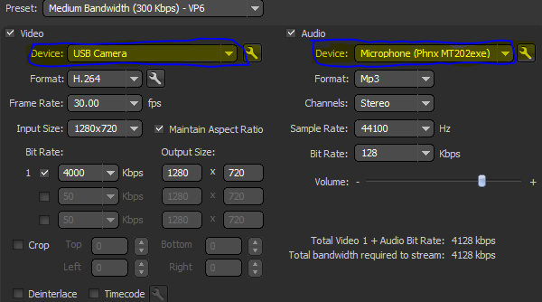
Once your equipment has been selected, and set up, you should see your USB camera feed in the preview window of Flash Media Live Encoder.
You should be good to click the green “Start” at the bottom of Flash Media Live Encoder.
Go back to Youtube Live and select the “Live Control Room” tab at the top.
Start the preview stream by clicking on the “Preview” button
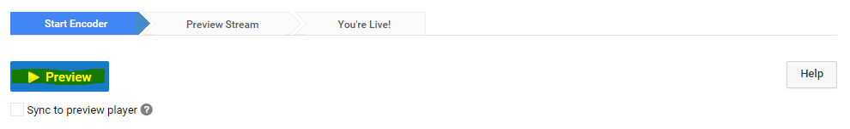
Then you will be able to start the actual stream by clicking “Start Streaming”
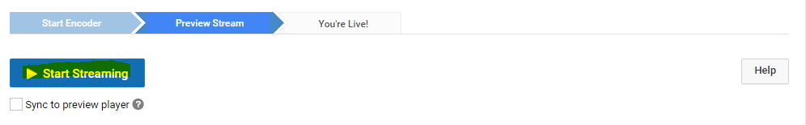
Once the stream has been initialized you can scroll down to the public view window in the YouTube Live page and monitor your stream by clicking the play icon. From this same “Public View” frame you can also get a shareable link to use for distribution of your live content.
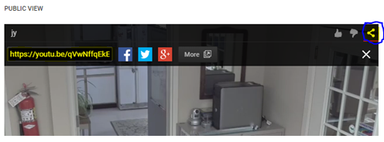
You’re now live streaming!
Special Note: The stream will not stop unless you go back up to the top of your “Live Control Room” page in YouTube Live and click “Stop Streaming”.
