Can I stream to Youtube from a HuddleCam?
Yes you can!
It can seem a little daunting at first, but streaming to YouTube from a USB camera is actually very easy. To get started the few things you will need are an operational HuddleCam and an active YouTube account.
Let’s start by logging into YouTube.
You should be able to click on 3 little horizontal lines in the upper left of the home screen.
Go to “My Channel”
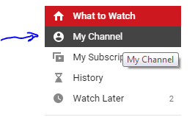
Now, you should be able to select the “Video Manager” tab from below the search bar.
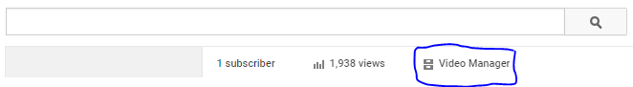
Go to “Live Events” and click the button on the top-right to create “New Live Event”
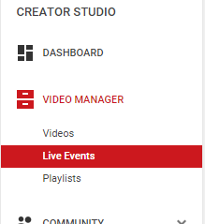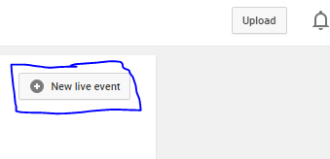
Next name your event, schedule a time for it, and set as public or private.
For the “Type”, make sure it is set to “Quick”.
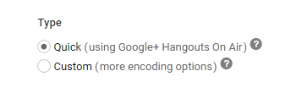
Now click the button to let you “Go Live Now”
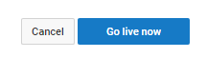
Next, you should be automatically brought into a Google Hangouts session. It should automatically select your camera, but if not, you can select your camera settings by clicking the gear in the upper middle of the screen. You can also set your audio setting here as well.
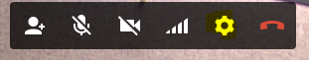
Now, you would click the button to “Start broadcast”
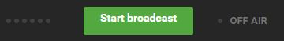
You should be live and streaming at this point. If You click the “links” tab at the bottom right of your screen you should be able to get a link to share with anyone you want to view the stream.
